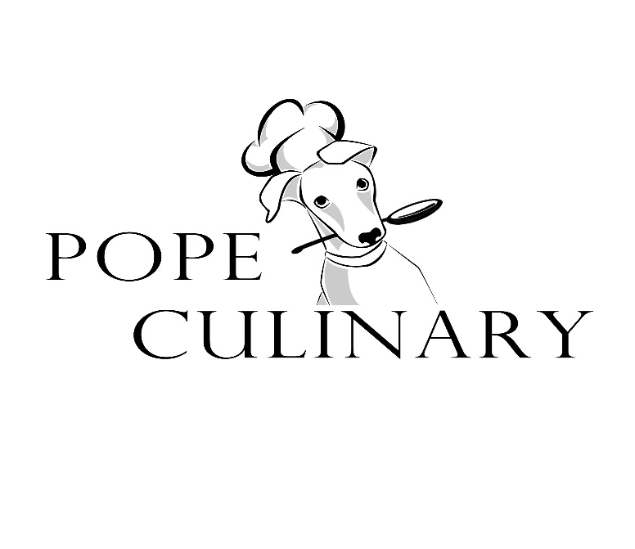
To promote professionalism and Industry standards, Pope’s culinary students are required to purchase and wear a chef’s jacket when participating in kitchen labs as well as any catering events that they may volunteer to participate. This can be purchased through the department for $20 per jacket. The jacket is then the student’s responsibility for the up-keep of the jacket and to bring to school on the day of lab. Failure to do will result in a “0” for the lab until it can be made up at home. If you have any questions, please feel free to contact me at Bradley.Klink@cobbk12.org. I can accept Cash, Checks (Made out to Pope High School or MyPaymentplus (https://www.mypaymentsplus.com/welcome)*.

Thank you,
Brad Klink
_______________________________________
Student Name
__________
Class period
______________
Size
______________ I already have one/will purchase on own.
*Surcharge will apply

